Mandatory Edible Food Recovery Requirements for Commercial Edible Food Generators
California’s Short-Lived Climate Pollutant Reduction law (SB 1383, Lara, Chapter 395, Statutes of 2016) establishes methane reduction targets for California, including a target to increase recovery by 20 percent of currently disposed of edible food for human consumption by January 1, 2025.
To meet the mandated statewide goal, the law requires each jurisdiction in California to establish and monitor a robust food recovery program, which will strengthen the relationships between commercial edible food generators and food recovery organizations within their communities, requiring certain food businesses to send the maximum amount of edible food they would otherwise dispose of to food recovery organizations.

What is Edible Food Recovery?
Edible food recovery is the act of diverting surplus edible food from businesses, organizations, or events that otherwise would previously have been disposed of in a landfill or sent to compost. This recovery service is carried out by food recovery organizations, such as food banks and other community-based organizations.
Edible Food Recovery helps eradicate food insecurity and waste and may lessen the effects of climate change by reducing methane gas emissions. You must contract for Edible Food Recovery services just like your other waste and recycling services. In Stanislaus County, and throughout the State of California, edible food recovery is now a mandatory program for many food generators, and failure to arrange for adequate services will result in fines and penalties.

Edible Food Recovery Requirements
The law phases food donors under two tiers. The first tier is required to donate starting in 2022. The second tier is required to donate starting in 2024. Mandated food donors can help their communities now by starting to work with local food banks, food pantries, and other food recovery organizations and services.

Establishing Contracts and Written Agreements
To ensure that the maximum amount of edible food is recovered, the regulations require that mandated food donors establish contracts or written agreements with food recovery organizations and services. Food recovery organizations and services vary in the amount and types of food they can receive, so mandated food donors may need to establish contracts or written agreements with multiple food recovery organizations and services to be in compliance.

Recordkeeping
The law requires mandated food donors to maintain records of their food donation activities.
CalRecycle has developed a model recordkeeping tool that commercial edible food generators can use to ensure compliance with recordkeeping requirements. The use of this specific tool is optional.

Defining Tier One and Tier Two Commercial Edible Food Generators
SB 1383 places commercial edible food generators into two tiers to allow businesses and jurisdictions time to expand or build new food recovery infrastructure and capacity to donate foods that are harder to safely store and distribute.

Commercial Edible Food Generators
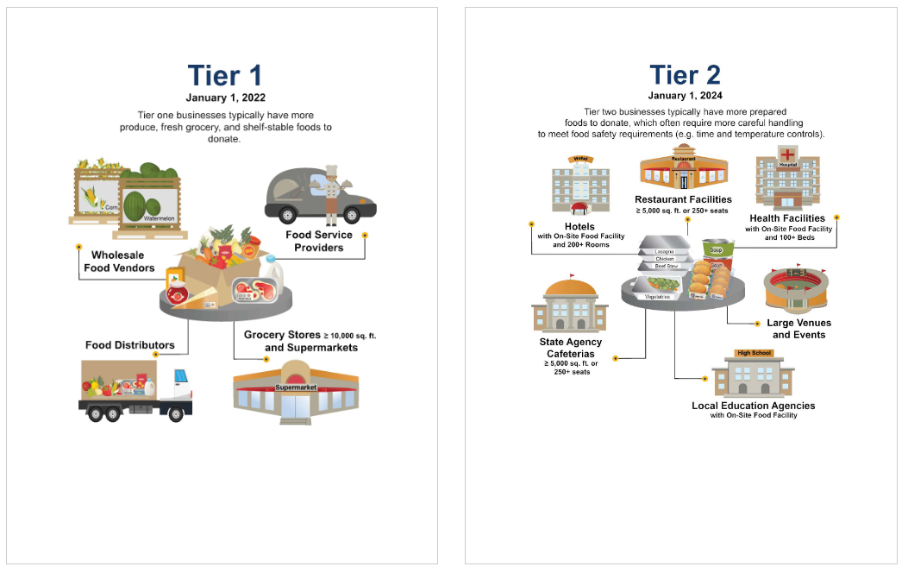

Tier One Donors
Required to Send Surplus Food to Food Organizations Starting January 1, 2022
- Supermarkets with revenue ≥ $2 million.
- Grocery Stores with Facilities ≥ 10,000 sq. ft.
- Food Service Providers
- Food Distributors
- Wholesale Food Vendors

Tier Two Donors
Required to Send Surplus Food to Food Organizations Starting January 1, 2024
- Restaurants with Facilities ≥ 5,000 sq. ft. or 250+ seats
- Hotels with an On-Site Food Facility and 200+ Rooms
- Health Facilities with an On-Site Food Facility and 100+ Beds
- Large Venues and Events
- State Agency Cafeterias with Facilities ≥ 5,000 sq. ft. or 250+ seats
- Local Education Agency with an On-Site Food Facility
- Non-Local Entities
The following are local Food Recovery Organizations. Please contact them for more information:
- Merced County Food Bank
2000 W. Olive Ave, Merced; (209) 726-3663
Service area: Merced County and Mariposa County
https://mmcfb.org/
Accepts non-perishables and fresh produce (such as uncut vegetables and fruit), and dry staple foods (such as beans and rice).
- Livingston’s People’s Fridge
1310 Main Street, Livingston (outside Emmanuel Baptist Church); (209) 205-8102
Service Area: Livingston
Accepts fresh fruits and vegetables 24/7.
https://www.peoplesfridge.org/locations

- Second Harvest of the Greater Valley
1220 Vanderbilt Circle, Manteca; (209) 239-2091
Service Area: the Greater Valley
Accepts unexpired food that has labels showing nutritional value and a list of ingredients, please call (209) 239-2091.
www.localfoodbank.org

